Effect of Periodic Autophagy on Adults with Symptomatic Long COVID - an Observational Study

Thomas Bunker¹*, Robert Carlson², Jenny Olson³
Affiliations:
- Independent Researcher, PhD in Immunology
- Data Analyst, MS in Civil Engineering
- Moderator of “Long Covid – Recover via Fasting / Autophagy” Facebook group
* Correspondence to: thomas_bunker@msn.com

Abbreviations:

SARS-CoV-2: Severe acute respiratory syndrome coronavirus 2
COVID-19: Coronavirus Disease-2019 where SARS-CoV-2 is the causative agent

Brief Summary:

PASC the long-term post-acute sequelae of COVID-19, hereafter referred to as Long COVID, is a serious public health crisis with no proven treatment. The periodic induction of putative cellular autophagy via a variety of methods is shown to be a promising novel treatment. About half of the ‘high compliance’ group saw a 50% or greater reduction in the number of their Long COVID symptoms. Of course, follow-up is urgently needed including confirmation of safety and efficacy via rigorous controlled clinical trials.

ABSTRACT

Hundreds of self-identified covid long haulers worldwide opted to follow the self-treatment outlined in the Autophagy Protocol. The key component of the protocol is the putative induction of cellular autophagy once or twice per week. Of the 158 long-haulers that submitted 2 or more weekly surveys and did something to induce autophagy, 111 (70%) reported a net decrease in symptoms. Among those that induced autophagy at least every 2 out of 3 responses and made changes to their diet, 46 out of 51 (90%) reported a net decrease in symptoms. 35 out of 51 (69%) had a net decrease of 3 or more symptoms. 49% (25 of 51) of the these ‘high-compliance’ participants saw a 50% or greater reduction in their initial number of Long COVID symptoms. Over 16 weeks there was a clear downward trend in the median number of symptoms reported by participants. For females the median number of symptoms dropped from 10 to 4. For males the median number of symptoms dropped from 8 to 4. Overall, after 20 weeks the median reduction in symptoms was 61.1%. The method of autophagy induction was important. After the first week, 2.5 day water fasts had the greatest average reduction in symptoms week to week with a net change of -0.54 symptoms. The most effective non-fasting method was 300 mg Resveratrol + 800 mg Quercetin with an average week to week reduction of -0.38 symptoms. While 2 Tbsp Olive Oil had an average reduction of -0.24 symptoms per week. The beneficial effect of three completely different interventions strongly supports the hypothesis that cellular autophagy is responsible for the reduction of Long COVID symptoms. Thirty-nine Long COVID symptoms were tracked via a weekly symptom survey. Nerve pain, muscle twitches, fatigue, brain fog, Post Exertional Malaise, chest pain, and tinnitus were reported to have gone away by between 22% and 33% of the ‘high-compliance’ participants. Tremors, heart palpitations, tachycardia, and chest pain were more amenable. Overall, 48% percent of all tracked symptoms resolved in the ‘high-compliance’ group. In two-thirds of the participants, based on the survey inflammation index, induction of putative autophagy corresponded to a temporary worsening of their existing Long COVID symptoms for 1 to 12 hours. 15.0% of the participants reported an initial net increase of two or more new Long COVID symptoms within the first 2 weeks of starting the Autophagy Protocol. Otherwise, few adverse effects were reported. Many respondents had one or more significant relapses as indicated by a response-to-response increase of three or more symptoms during their reporting period. Overall, the monthly relapse rate was 37% but varied from 60% for middle-age females to 5% for older males. Overall, females were 2.5 times as likely as males to experience a significant relapse. The least active participants pre-covid had the best recovery rates while the pre-covid “fitness fanatics” had the worst recovery rates. One weakness of this study is the lack of a predefined control group. However, a plot of the median number of symptoms from 338 initial surveys versus length of time as a long-hauler suggests that without the autophagy protocol self-treatment the median number of symptoms may actually be increasing over time. Long-haulers reported a median of 11.0 symptoms during their first 8 months versus a median of 12.0 symptoms from 9 months or longer. To establish the safety and efficacy of these widely available and inexpensive home remedies, it is crucial that the results of this pilot observational study be followed-up with one or more robust clinical trials.

MAIN
SARS-CoV-2 infection leaves behind residual viral debris in a wide variety of tissues and cell types that express the ACE2 receptor. These include vascular endothelium, blood, bone marrow, brain and lung pericytes, brain, gut epithelium, lung, heart, aorta, kidney, liver, thyroid gland, adrenal gland, gallbladder, lymph nodes, muscles, reproductive organs, eyes, and nasal epithelium^{1–8}. Two studies of the immunological response in PCR-Positive Covid-19 individuals indicate that viral antigen persistence occurs in a percentage of people infected with SARS-CoV-2^{9,10}. Indeed, viral spike protein fragments have been detected in non-classical monocytes from covid long-haulers even at 15 months post-acute covid¹¹. Additionally, viral RNA and protein were detected in nasopharyngeal samples 4 to 6 months post Covid-19 onset¹².
Autophagy is one of the two main degradative pathways in our cells and can be used to degrade viruses, viral nucleic acids and misfolded viral protein aggregates. It has been proposed that increasing autophagy may have a therapeutic effect against Coronaviruses although many viruses manipulate the autophagic machinery to their own advantage^{13,14}. Autophagy is also known to be integral to the process of viral antigen presentation via MHC-II, which allows CD4+ T cells to direct immune responses (Natural Killer cells and Cytotoxic CD8+ T cells) towards infected cells^{15,16}. SARS-CoV-2 is known to encode for at least one viral protein, ORF3a, that interferes with autophagy by blocking the fusion of autophagosomes with lysosomes¹⁷. In an attempt to overcome the viral blockage of basal low-level autophagy, a variety of interventions were chosen to attempt to strongly trigger cellular autophagy. Interestingly, two-thirds of long-hauler respondents reported transient increased inflammation and increased severity of symptoms; typically for 2 to 6 hours following putative autophagy induction. Often a long-hauler’s headache or gut ache or muscle ache, rapid heart rate or other symptoms become noticeably worse. If the signs extended into the night, autophagy consistently resulted in difficulty sleeping. Sometimes increased inflammation or new inflammation of various organs including the heart, kidney, or gall bladder was felt. One possible explanation is that autophagy related antigen presentation of viral fragments is triggering an increased transient localized immune reaction. The average increase in inflammation was similar for all autophagy methods - though quite variable between participants (Figure 1 Inflammation by treatment)
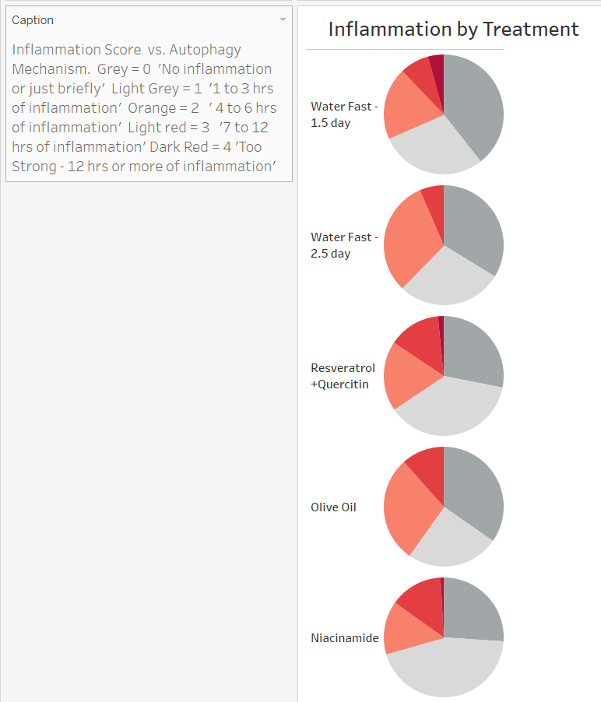

The Autophagy Protocol

The Autophagy Protocol was initially created based on the Long COVID recovery experiences of Tom Bunker. He developed Long COVID in May of 2020 and recovered fully by August of 2020 via time-restricted eating while following a low sugar, no processed carbohydrate diet with one longer water fast. Based on symptoms, he caught covid again in late September and developed significantly worse Long COVID in mid-October after backpacking for a weekend. He began experimenting with various known autophagy inducers such as Metformin, Resveratrol, Quercetin, Spermidine, Trehalose, Nicotinamide Riboside, Beta hydroxybutyrate, Hydrogen Water, etc. based on his increased Long COVID symptoms of gut ache and headache and “feelings” of autophagy such as edginess and a slight jittery/shaky feeling. Typically, the signs of autophagy would happen in the evening beginning about 6 pm and last until 10 pm. However, some methods of autophagy triggered these indicators of autophagy within 1 hour - no matter the time of day. The key element of the Autophagy Protocol is the periodic induction of strong Autophagy once or twice a week. In addition, the Autophagy Protocol recommends following a no added sugars, no processed carbohydrates diet, daily time-restricted eating in an 8 or 10 hr window, and avoiding all moderate and strenuous exercise. It also includes a list of recommended supplements including 2000 IU of Vitamin D, 500 mg Vitamin C, 100mg Vitamin B3, 600 to 750 mg NAC, 500 to 800 mg Quercetin and a daily multi-vitamin.
After Mr. Bunker created a Facebook group in December of 2020 devoted to experimental recovery from Long COVID, thousands of people from around the world tried the Autophagy Protocol. Many have shared their experiences – both positive and negative through online posts in the ‘Long COVID – Recover via Fasting / Autophagy’ group. To collect data on the self-treatment regime, Mr. Bunker created an online Weekly Long COVID Symptom Survey in Dec 2020 and enabled volunteers to track their symptoms and their method of putative autophagy each week. A PDF detailing the protocol was developed and it includes a list of medicines and supplements to avoid as they are potential autophagy inducers. Some very common items made the long list. Statins, Metformin, Ivermectin, Omega 3 Fish Oil, Tumeric extract/Curcumin, MCT Oil etc^{18–24}. A few medicines were put on the list to avoid as they may block autophagy; namely Colchicine²⁵, the beta blocker Propanolol²⁶ and the anti-malarial drugs Chloroquine and Hydroxychloroquine²⁷.

Net decrease in Long COVID symptoms while following the Autophagy Protocol

126 self-identified covid long haulers filled out 2 or more weekly symptom surveys. After filtering out those that did not report attempting to induce autophagy on at least one-third of their weekly responses, 116 respondents were left. The demographics were 53% females, 47% males, average age of 41, ranging in age from 20 to 68 years old. Of those, 76% reported a net decrease in symptoms from their initial survey to their last survey. (Figure 2 Net Change in Symptoms - minimum 33% Autophagy) The average net decrease in symptoms for these responders was minus 4.8 symptoms. While the average duration of following the protocol was 7.9 weeks, 15 participants followed it for 20 weeks or more.
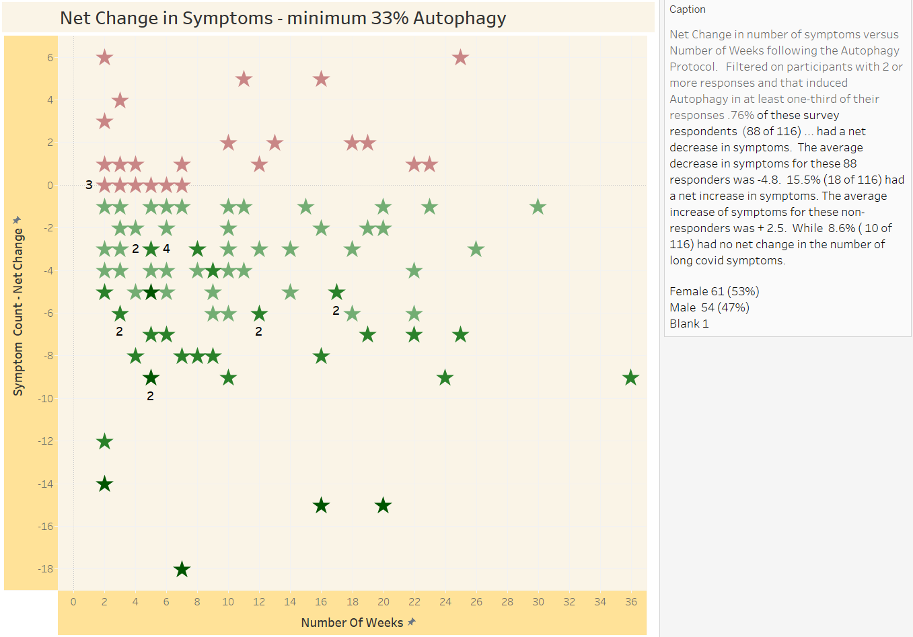
When filtering out those that induced autophagy less than two-thirds of the weekends 86% of the respondents had a net decrease in symptoms. After further filtering for those that followed some form of special diet, 90% (46 of 51) of the remaining survey respondents reported a net decrease in symptoms. 69% of this “high compliance” group saw a net decrease of 3 or more symptoms. 49% (25 of 51) of the high-compliance participants saw a 50% or greater reduction in their initial number of Long COVID symptoms. (Figure 3 Percent Initial Symptoms - 66% Autophagy, Special Diet) The greatest net decreases in symptoms reported were -18, -15 and -15 reported by three participants over 7, 16 and 20 weeks respectively. Three of the participants reported no Long COVID symptoms. Note that zero symptoms does not equate to full-recovery. From the personal experience of one of the authors (TB) and anecdotal reports, even those that get to zero symptoms can relapse. These unexpected relapses typically happen 2 days following moderate or strenuous exercise and can occur even after 12 weeks with no symptoms.

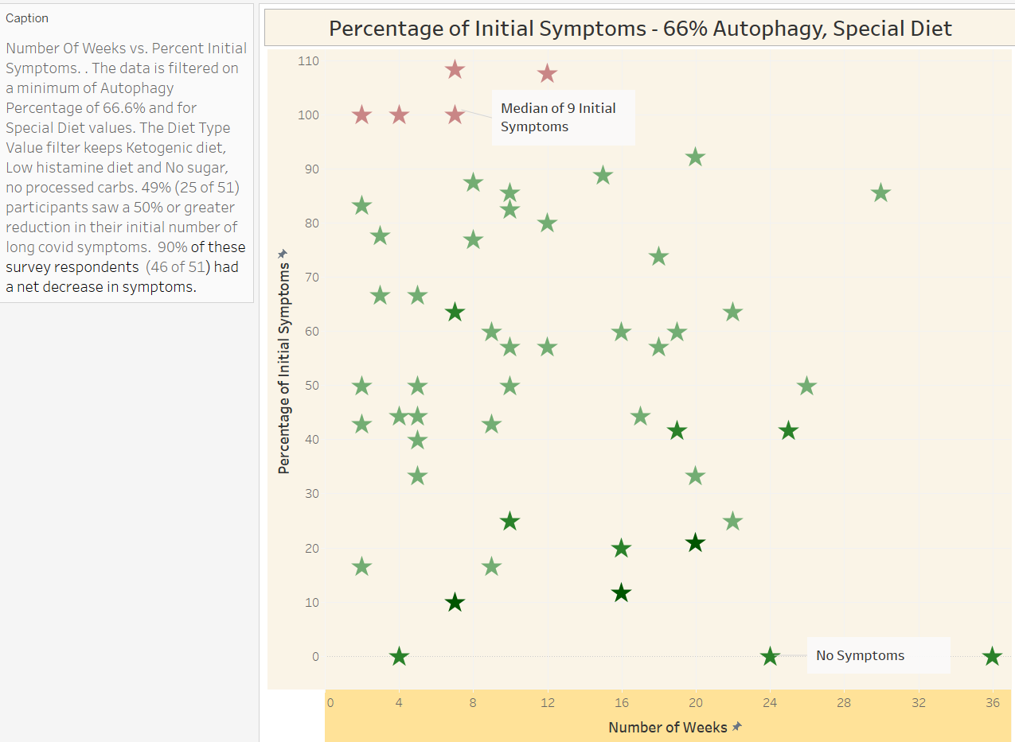

Long-term trend of Long COVID symptom

It is difficult to imagine an adequate control group for a volunteer self-treatment program. Especially when so many “extra” supplements and medicines could be impacting participants ability to induce cellular autophagy. The next best thing is to simply look at the trend of Long COVID symptoms over time. If there is a downward trend over time, then that complicates attributing any decrease in symptoms to the autophagy protocol. On the other hand, if the trend is flat or upward, then any improvements are more likely to be significant. 340 long haulers filled out initial symptom surveys that collected this data. Overall, the median number of tracked Long COVID symptoms was 11.5. This is a likely a low estimate as many lower frequency symptoms and symptoms requiring a medical diagnosis were not tracked. When grouped into those that had Long COVID from 1 to 8 months (11.0 symptoms, n=222) and those that had Long COVID 9 or more months (12.0 symptoms, n=116), there was a 9% increase in the median initial number of symptoms. Figure 4 (Median Number of Symptoms by Months with Long COVID) If significant, this is a concerning trend as many long haulers are already having difficulties functioning at a high enough level to maintain their jobs and to take care of their families. At the very least, the lack of a downward trend reflects the growing frustration and angst in the covid long haul community and the current lack of effective medical treatments. Differences in the gender ratio do not account for the slight upward trend (data not shown).
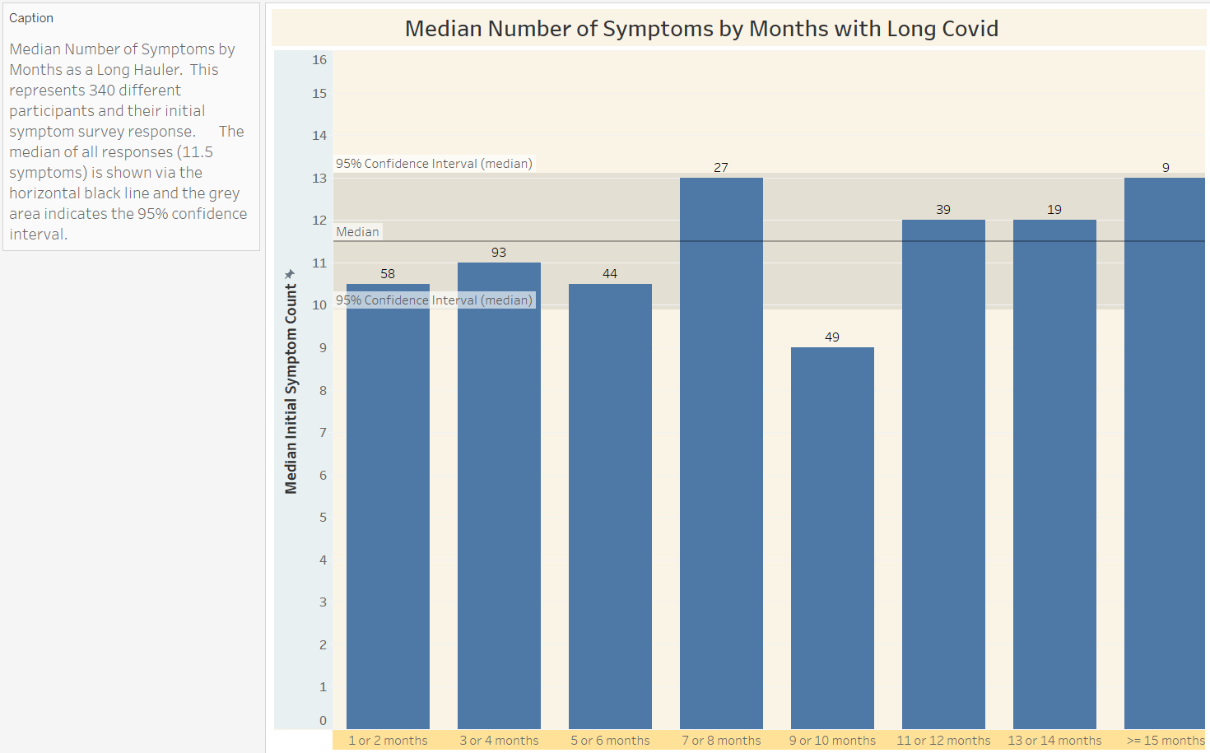

Median recoveries while following the Autophagy Protocol

There is a pronounced downward trend in the median number of symptoms by number of weeks on the protocol. Figure 5 (20 Week median Recovery via the Autophagy Protocol). The survey response dates were used to calculate the number of weeks following the protocol. The median number of initial symptoms reported was 10.0. The median number of symptoms reported after 20 weeks of following the protocol was 3.5. 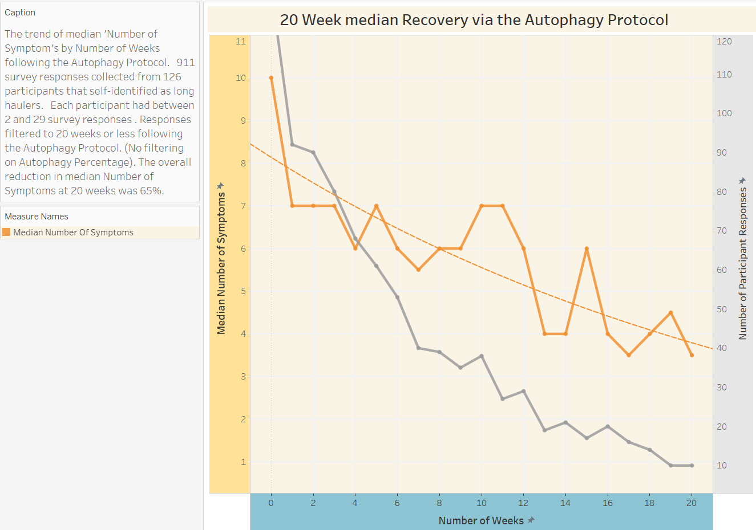 This corresponds to a decrease in the median number of symptoms of -0.325 per week. Notice however that the rate of symptom reduction is not constant, instead it gradually decreases over time. The week 19 and 20 data points were calculated based on only 20 participant responses while the week 1 and 2 data points were based on 120 and 85 responses. That is a definite weakness of this analysis; it does not follow the same participants each week. It could be argued that only those seeing success persist with the protocol. However, Figure 2 shows that 24% of the participants stuck with the protocol even when they experienced no net decrease in symptoms. While females began the protocol with a median of 3 more symptoms on average than males, the gender recovery trends converged by 16 weeks. Females reported a decrease from 11 to 4 (64.0%) in the median Number of Symptoms over 16 weeks. Males reported a decrease from 8 to 4 (50.0%) in the median Number of Symptoms over 16 weeks. Figure 6 (Median Recovery by Gender via Autophagy Protocol). Surprisingly, participants that had been long haulers for 11 months or greater had a better recovery trend line than those than had been long haulers for 10 months or less (data not shown).

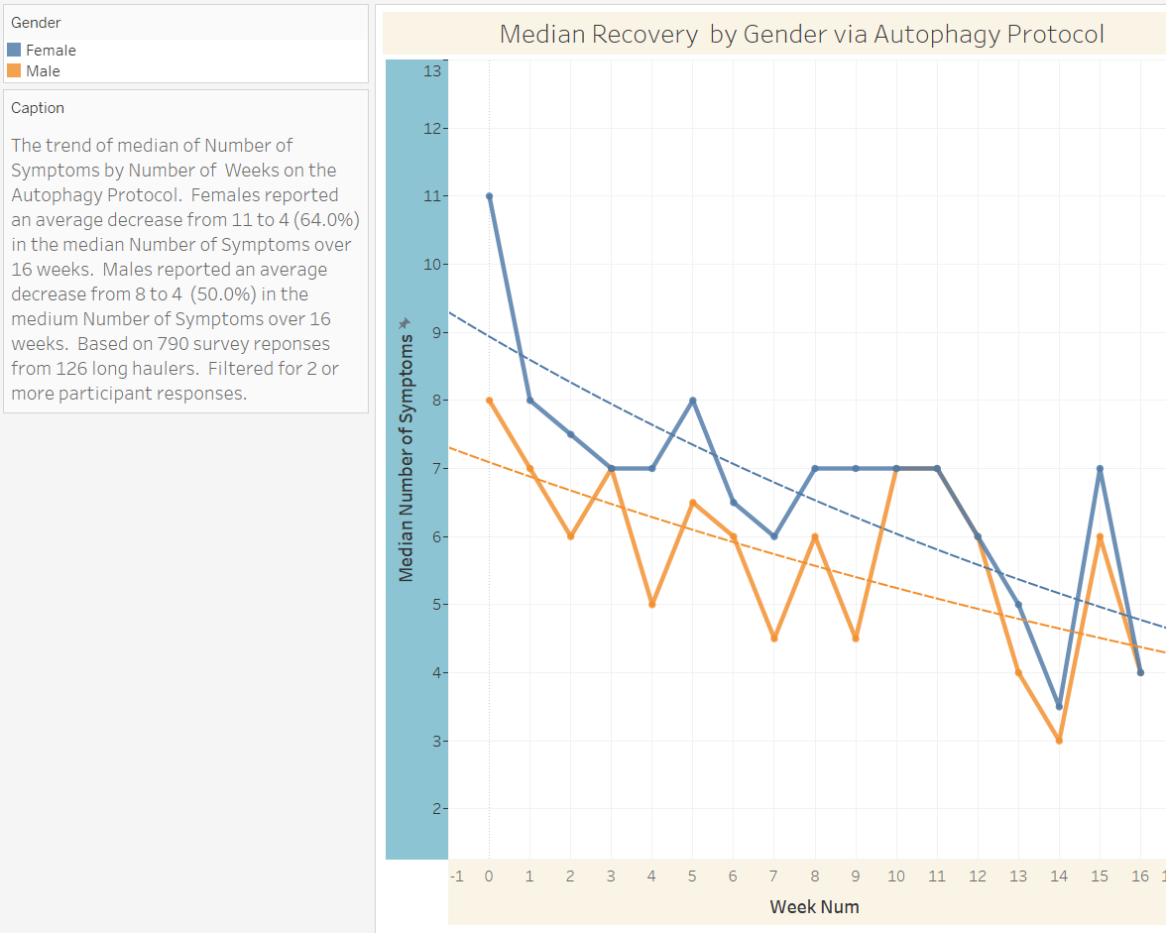

Characteristics of Autophagy Treatment - Initial Symptom Bump

15.0% of the participants reported an initial net increase of two or more Long COVID symptoms within the first 2 weeks of starting the Autophagy Protocol. 7% of the participants reported an initial increase of 3 or more symptoms with the first 2 weeks of starting the Autophagy Protocol (data not shown.) Anecdotally, a number of long haulers have reported increased severity of their existing symptoms and new Long COVID symptoms for 3 or 4 or 5 days after their initial short water fast or other autophagy induction method. Sometimes participants said they had to cut short their planned fast because of the discomfort of their increased symptoms.

Methods of Autophagy - compared for Week 1 vs After Week 1

To compare the relative efficacy of the various methods of inducing putative autophagy in responders, the week to week change in the number of symptoms was used as a gauge. Responders were defined as those participants that saw a net decrease of 1 or more symptoms. The underlying assumption is that each symptom has a threshold level of viral debris in a particular tissue or cell type below which the symptom is gone. If one method of autophagy is more effective than another at degrading viral debris then that should be reflected in the average decrease of symptoms from the previous week’s response. Note that the weekly surveys were typically done on a Friday while autophagy typically was attempted on Saturday and/or Sunday. To better account for the initial sudden decrease in symptoms the methods were compared for the first week on the protocol and after the first week on the protocol. For the first week, both 1.5 day and 2.5 day fasting were similar with an average weekly symptom reduction of -.77 and -.80 respectively. Figure 7 (Weekly Symptom Reduction by Method -1st week). The best non-fasting method was Olive Oil with an average -0.33 symptom reduction. After the initial week, the average weekly rate of symptom reduction reduced for all methods except Quercetin + Resveratrol. 2.5 day fasting and Quercetin + Resveratrol then become the most efficacious with average weekly symptom reductions of -0.54 and -0.38 respectively. Figure 8 (Weekly Symptom Reduction by Method after 1st week). It turns out that frequent relapses, i.e. increases in symptoms, dramatically impact the average weekly symptom reduction values. When relapses, defined as an increase of 3 or more symptoms are excluded from the responses, the average Weekly Symptom Reduction values all increase dramatically. For example, 2.5 day fasting increases from -0.54 to -1.7 and Resveratrol plus Quercetin increases from -0.38 to -1.29. Of course, this reflects more what is theoretically possible rather than what is seen in reality, although a very few long haulers did report dramatic decreases in their symptoms.
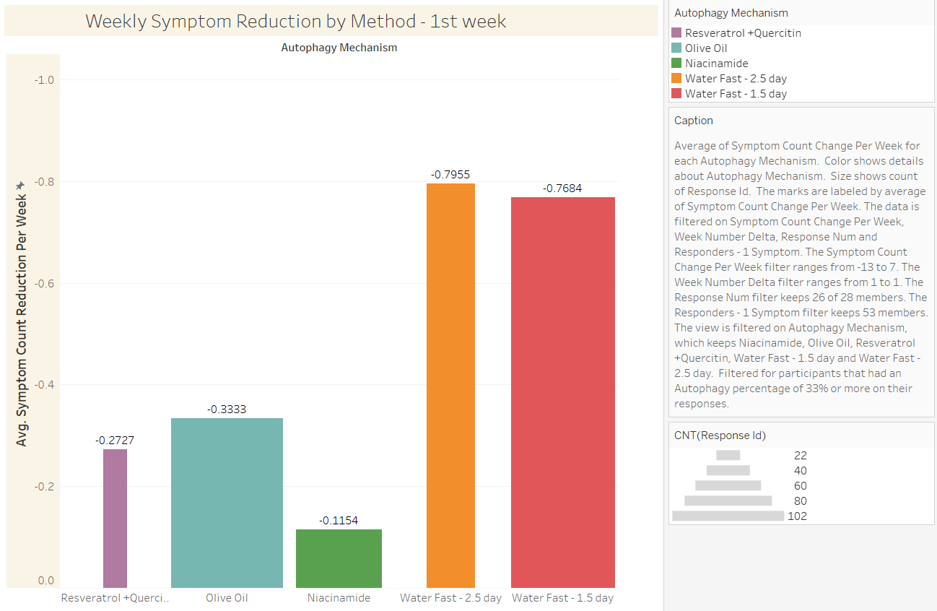
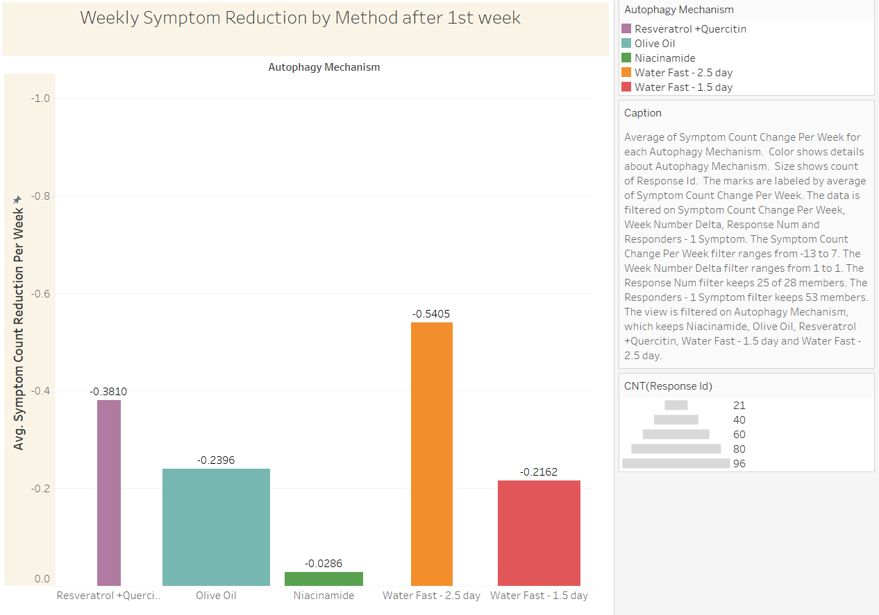

Relapses by Gender and Age Group

Overall, the monthly relapse rate was 39% but varied from 60% for middle-age females to 5% for older males. Overall females were 2.5 times as likely as males to experience a relapse. Figure 9 (Percent Relapses per Month by Gender and Age Group) Interestingly, when a relapse was defined as a net increase of four or more symptoms, then younger females had more frequent relapses (48%) than middle-age females (34%). Clearly the high relapse rate creates a significant (and frustrating) headwind for many covid long-haulers. When participants were filtered for at least 66% autophagy, the overall relapse rate per month dropped from 39% to 27%.

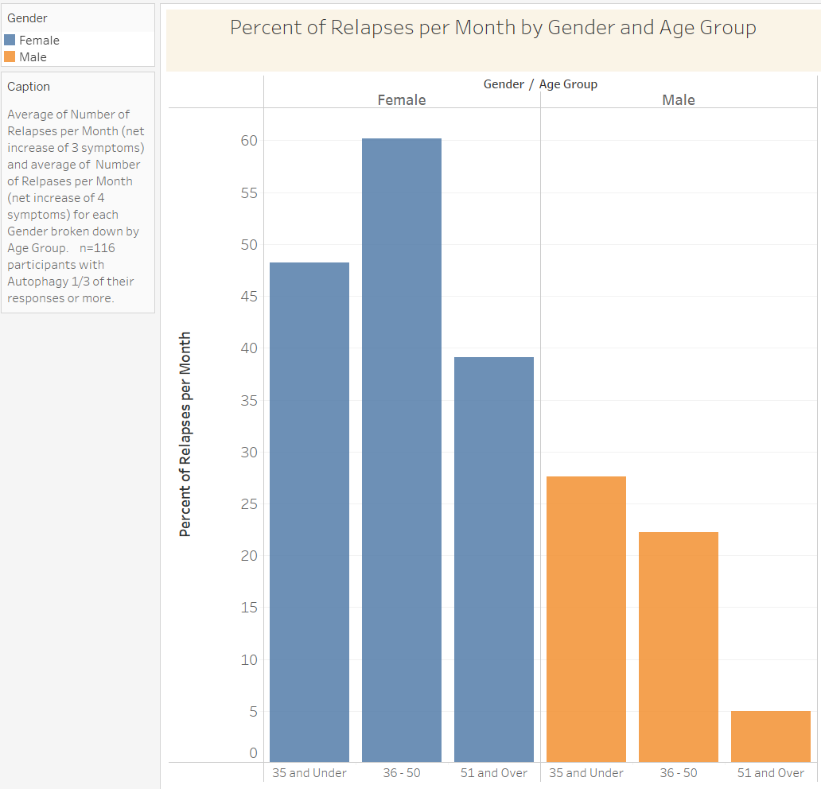

Characterization of Long COVID

Since many with Long COVID have some week-to-week variation in their symptoms, it is important to look at frequency of symptoms reported over a longer course of their illness. When this is done the frequency of many symptoms by participant increases significantly. This diagram Figure 10 (Symptom Frequency by Participant) may prove helpful to assist in diagnosis of Long COVID based on patient symptoms. It is especially useful if a potential long-hauler tracks their symptoms over a period of a month or two. Here the average number of survey responses for participants is 5.8. In this sample of Long COVID symptoms, 16 symptoms occur at a frequency of 50% or greater in participant’s aggregate symptom surveys. Note that two common early and acute Covid-19 symptoms; fever (8.6%) and anosmia (15.5%) occur relatively infrequently in long haulers. Also note the relatively frequent occurrence of mental health symptoms; suicidal thoughts (11%), depression (35%), insomnia (66%) and anxiety (69%). There are a number of Long COVID symptoms not captured below including hair loss, constipation, diarrhea, acid reflux, gall bladder pain, irregular menstrual cycles, blurry vision, increased eye floaters, tooth aches, difficulty swallowing and liver pain.

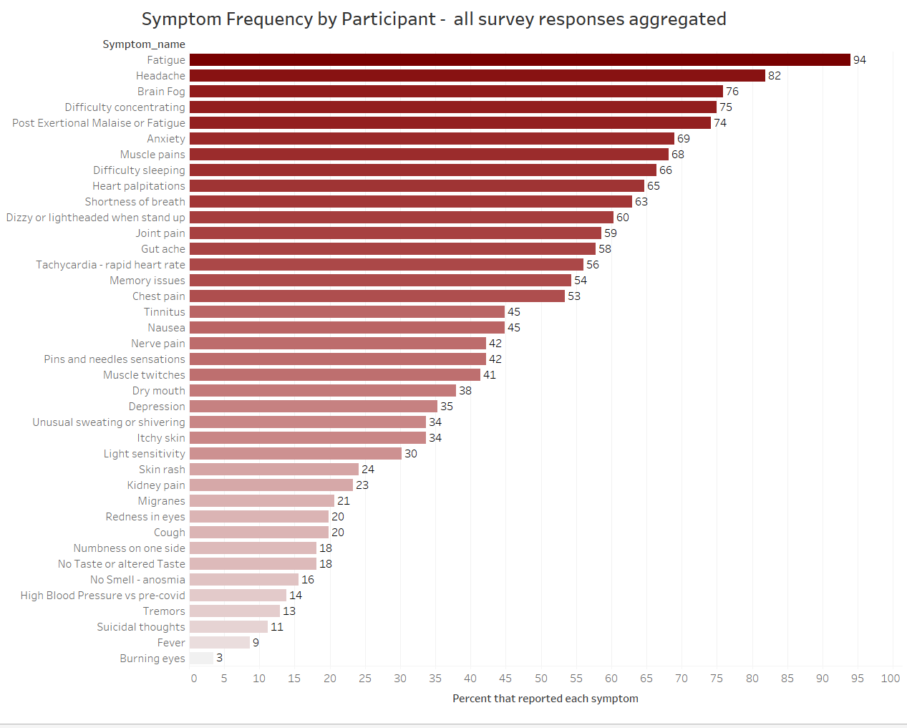
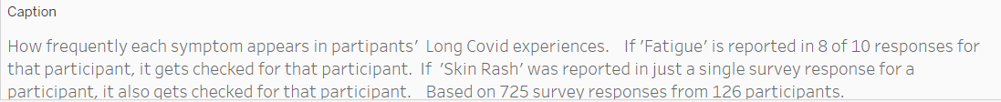

Long COVID symptoms that respond to the autophagy protocol

At least 20% of the 116 survey participants (that induced putative autophagy in one-third of their responses or more) reported every Long COVID symptom that was tracked as resolved. Overall, 40% of participant symptoms resolved. When filtered to the 51 ‘high compliance’ participants that induced putative autophagy in at least 66% of their responses, 48% percent of all symptoms resolved. Not surprisingly, some symptoms were harder to get rid of than others. Nerve pain, muscle twitches, fatigue, brain fog, Post Exertional Malaise, chest pain, and tinnitus were reported to have gone away by between 22% and 33% of the participants. Of the top 20 most common symptoms the ones that most frequently disappeared were difficulty sleeping (67%), difficulty concentrating (64%) and nausea (60%). Figure 11 (Percent Recovered by Symptom – 66%) These ‘high compliance’ participants saw 23 of the 39 tracked symptoms resolve 50% or more of the time. Since some long haulers have frequently changing symptoms instead of constant symptoms, a symptom was only marked as recovered if it went away and stayed away for 2 or more weeks and did not reoccur again in subsequent responses for that participant. All tracked symptoms had a higher recovery rate in the 66% Autophagy group compared to the 33% Autophagy group except for Nerve Pain (22% vs 40%) and Chest Pain (32% vs 36%). Given the relatively small of participants with these symptoms these differences may not be significant.

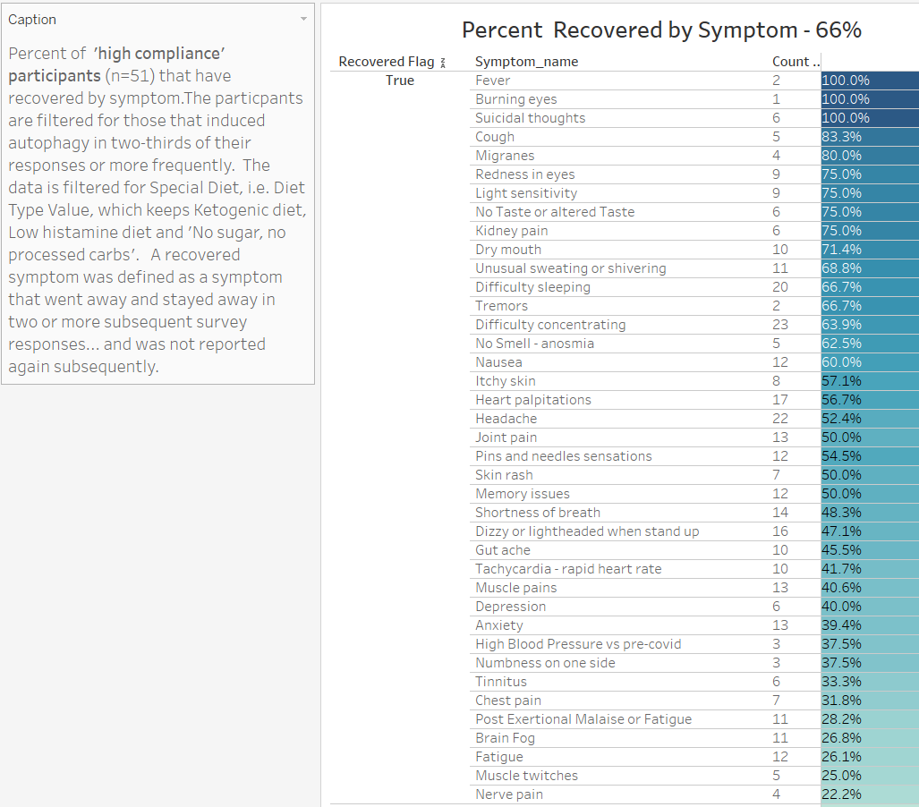

Inverse correlation between pre-Covid activity level and average recovery rates

Participants general health and activity level prior to their Covid-19 infection and subsequent development of Long COVID could potentially affect the speed of their recoveries. To look for a possible correlation the participants were segmented into 4 groups reflecting various daily Activity levels. Surprisingly, the participants that had been the most active, calling themselves “fitness fanatics” as a group had the worst average recovery rate with a downward slope of only -0.05. While the group that was the least active, walking 5000 steps or less a day, had the best average recovery rate with a downward slope of -0.33 on their recovery trend line. Figure 12 (Recovery by pre-Covid Activity level) The week 1 responses were excluded for this analysis to get to the more linear part of the recovery curve. Data points with just a single participant were also excluded from the plot. Anecdotally, two of the authors (TB and JO) have talked with many long haulers that either had their initial Long COVID symptoms develop after strenuous exercise or that suffered significant relapses after moderate or strenuous exercise. These reports are consistent with the idea that Fitness fanatics are more likely to attempt to continue their exercise habits, even when not fully recovered from Long COVID. Interestingly, participants in the older age group of 51 and older had a much better average recovery trend line (slope of -0.33) compared to the younger age groups. The average recovery trend line for 35 and under was actually positive (slope of 0.05)(data not shown).
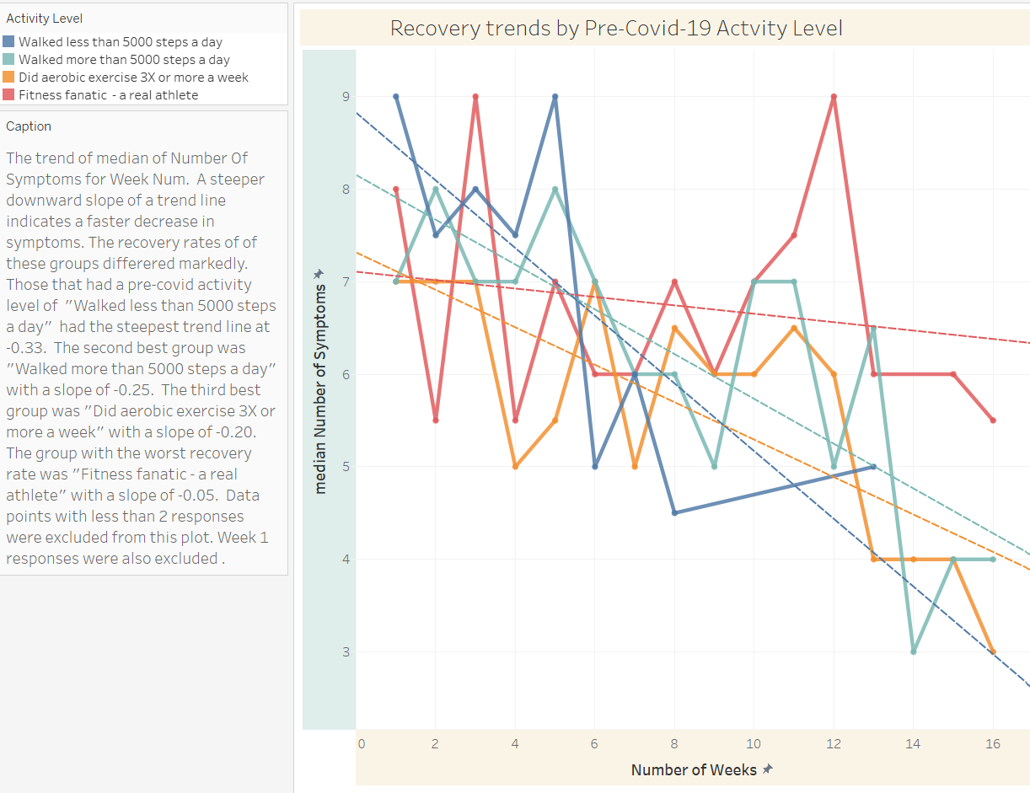

Safety and Side-effects

Overall, only 1.6% (9 of 571) of the survey responses indicated “Too strong - greater than 12 hours” of inflammation following the induction of putative autophagy. There have been a few reports of urine turning brown the day after ‘Too strong’ autophagy. This may reflect clearance of cellular debris after either apoptosis or death of virally infected cells via Killer T cell activation. 168 of 1337 (12.6%) survey responses indicated that participants experienced negative side-effects from the diet, fasting or autophagy induction – other than transient increased inflammation. One of the rare negative side-effects was clearly fasting related; namely hypoglycemia. By far the most common complaint was fatigue, increased fatigue or severe fatigue. The second most common complaint was increased heart rate and dizziness. The other reported side-effects were consistent with the typical but incredibly varied Long COVID symptoms: headache, anxiety, difficulty sleeping, muscle aches, shortness of breath, kidney, right-side abdominal pain, nausea, vomiting, gut ache, irritability, sinus/tooth pain, runny nose, diarrhea, allergies, joint paint, PEM, eye issues, slow heat rate, heart palpitations, vertigo, itching, dry mouth and burning sensations. Unfortunately, one 68 years old female whom had already lost 75% of her vision to Long COVID/macular degeneration reported complete loss of vision during her second month on the protocol. Ironically, this participant reported that overall, her symptoms had improved that week. The increased inflammation following autophagy induction could potentially be detrimental to those with vision or other sensitive health concerns.

DISCUSSION

Coronaviruses appear to alter the two main cellular degradative processes, the ubiquitin-proteosome system and the autophagy-lysosome system for their own benefit. Some viruses are able to hide from the immune system by suppressing antigen presentation both via the ubiquitin-proteosome-MHC class I system and via the autophagy – lysosome – MHC class II system. SARS-CoV-2 does this by lysosomal targeting and degradation of MHC-I via the viral ORF8 protein²⁸. Also, the ORF3a protein has been shown to block fusion of autophagosomes with lysosomes by destabilizing the HOPS complex.¹⁷ORF7a may prevent the normal acidification of lysosomes further interfering with normal autophagy. Nsp15 affects the mTOR axis. Additionally, the expression of viral proteins such as envelope (E), membrane (M), ORF3a, and ORF7a result in an accumulation of membrane-associated LC3B, a marker of autophagosomes²⁹. Together, these perturbations in the autophagic flux likely promote SARS-CoV-2 replication and aid in evasion from immune responses.

It is proposed here that the viral blockage of autophagosome/lysosome fusion, lysosomal degradation and MHC-II viral antigen presentation can be overcome with the periodic induction of strong autophagy. Further, during autophagy viral RNA can activate Toll-Like-Receptors such as TLR7 in the lysosomes leading to the release of cytokines such as Interferons that indicate viral infection^{30,31}. Many long haulers report that they can “feel” when autophagy happens (personal communications). And those that follow the protocol successfully report that their “feelings” of increased localized inflammation - reflecting putative viral protein degradation - gradually decrease over several months of periodic autophagy induction and may go away completely. This implies that, at least in some long haulers, SARS-CoV-2 viral debris can be successfully cleared from infected cells and tissues over time.
Autophagy is a key cellular process that degrades damaged proteins and mitochondria in the lysosomes thereby recycling amino acids and other components to provide a short-term supply of nutrients for cellular functions. Autophagy is triggered by a wide variety of cellular stresses including nutrient deprivation, oxidative stress, imbalance of lipids, hypoxia, and damage to DNA and upregulates or down regulates many cellular pathways to return the cell to a healthy state. mTORC1, aka mTOR, is a key regulator of cellular metabolism and autophagy³² When the process of cellular autophagy is selective for degradation of viruses via certain adapters, it is known as Virophagy. It is currently unknown if the putative autophagy induced via the Autophagy Protocol is selective for SARS-CoV-2 virions or proteins. An exponential-asymptotic trend line fits the average recovery data points better that a linear trend line. This is consistent with the idea that only a percentage of viral proteins are degraded with each round of autophagy. It also implies that getting to 10% of the original viral load is much easier than getting to 0.00% of the viral load. Fasting is well known to induce cellular autophagy^{33,34}. The nutrient deprivation or shortage of amino acids and glucose causes the body to down-regulate glucose metabolism and switch to burning fatty ketones for fuel. As liver glycogen reserves are used up, the mTOR protein complex senses nutrient deprivation and the decreased energetic status of the cell via AMPK and initiates autophagy³⁵. Quercetin has been shown to inhibit mTOR and cause ER stress and induce autophagy via activation of SIRT1³⁶. Resveratrol has also been shown to inhibit mTOR and activate autophagy³⁷. Recently Resveratrol was shown to inhibit SARS-CoV-2 replication in cell culture³⁸. Hydroxytyrosol (HT) is a phenolic compound in olive oil that has antioxidant and anti-inflammatory effects and promotes autophagy³⁹. Research has revealed that HT can activate the silent information regulator 1 (SIRT1) pathway to induce autophagy⁴⁰. Likewise, Niacinamide (aka Nicotinamide) induces autophagy and can help clear damaged mitochondria⁴¹. Likely it boosts cellular NAD+ levels thereby activating the SIRT1 deacetylase and triggering autophagy⁴². That people with Long COVID experience similar feelings of increased symptoms from fasting, Olive Oil, Resveratrol plus Quercetin, and many other autophagy inducers strongly suggests that cellular autophagy is resulting in degradation of viral proteins in infected cells in various tissues resulting in increased inflammation due to presentation of viral antigens. Long haulers are reporting these increased aches and pressure in their heads, sinuses, chests, throats, muscles, guts, kidneys and various other locations.

It is interesting that 2.5 day fasting shows the greatest average weekly symptom reduction. It is even more curious that 2.5 day fasting appears to be 2.5 times more effective than 1.5 day fasts after the 1st week on the Autophagy Protocol. Based on the relative duration of the fasts only a 1.6 fold increase in symptom reduction would be expected. Fasting initially triggers autophagy via nutrient deprivation sensors and inhibition of mTOR, but after a period of time macroautophagy is down-regulated and chaperone mediated autophagy (CMA) is turned on³³. CMA uses HSP70 as an adapter to directly transport certain cellular enzymes to the lysosome for degradation and recycling of the amino acid building blocks⁴³. CMA also enhances the degradation of Lipid Droplets by targeting them to the lysosome⁴⁴. Generally, only cystosolic proteins with the KFERQ motif are degraded via CMA. Most are involved in glucose metabolism. It would be somewhat surprising if CMA is able to target any of the key SARS-CoV-2 proteins. Perhaps the increased lipophagy, i.e. lipid droplet degradation, is especially beneficial. Indeed, in cell cultures, SARS-CoV-2 proteins are associated with lipid droplets and have been shown to promote viral replication⁴⁵. Alternatively, the 2.5 day fast could potentially have a more positive impact on the immune system’s anti-viral response.

There is a huge need for effective Long COVID treatments. Anyone wanting to learn about Long COVID from a patient perspective can easily do so by spending a few hours on one of the many Long COVID online forums. Some of these have over a hundred thousand members. Few with Long COVID are hospitalized but many are unable to work full-time or properly take care of their families. Perhaps 14% to 30% of those infected with SARS-CoV-2 go on to be negatively impacted by continuing and new symptoms at 3 months and beyond^{46,47}. When you factor in the debilitating fatigue, anxiety, insomnia, brain fog, decrease in mental function and general rapid aging associated with Long COVID the human suffering and economic impact is likely many times that of AIDS and influenza put together. The long-term impact may even prove greater than that of acute Covid-19. Currently, treatments for ME/CFS such as graded exercise therapy are being tried on long haulers. Beta blockers, steroids, statins, anti-depressants, anti-anxiety medicines are being prescribed by well-meaning specialists. But no proven medical treatment exists that addresses the root cause of the long Covid symptoms. We are in a frightening public health crisis. One proposed treatment is the FLCCC Recovery protocol. It is notable that it includes a number of autophagy inducers; Ivermectin²⁰, Fluvoxamine⁴⁸, Atorvastatin⁴⁹, and Omega 3 Fish Oil²². However, the long-term safety of Ivermectin at 0.2 or 0.4 mg/kg taken daily is not well established as Ivermectin has been shown to have cytotoxic effects^{50,51}. Interestingly, another autophagy inducer, fenofibrate, is showing promise for treating acute covid^{52–55}. Retrospective studies suggest a beneficial effect for Metformin and Statins on Covid-19 symptoms and survival^{56–58}. A number of other autophagy inducers are in observational studies or clinical trials for either Covid-19 or Long COVID; Omega 3 Fatty Acids⁵⁹, Resveratrol⁶⁰, Fisetin^{61,62}, Quercetin^{63,64}, Rapamycin/Sirolimas^{65,66}, Niclosamide^{67–69}, NAD+⁷⁰ and Nicotinamide Riboside⁷¹.

An important part of the autophagy protocol is dietary changes. Many long-haulers have symptoms similar to that of Crohn’s disease and impaired autophagy in the lining of the gut could potentially be directly responsible^{1,6}. Daily, time-restricted eating, avoiding added sugars and processed grains is similar to diabetic diets that strive to minimize spikes in insulin and insulin-like growth factor. As these are both pro-growth hormones, limiting their production may help to decrease potential viral replication. Anecdotally, many long-haulers feel much worse if they eat a sugary treat and may have long thin stools afterwards. As many long-haulers have impaired intestinal function the elimination of all wheat appears beneficial for the majority of long haulers. In general, the diet recommendations for those with Crohn’s disease or ulcerative colitis are helpful for long-haulers. Interestingly, a study found that healthcare professionals following diets rich in vegetables, legumes, nuts and fish were less likely to have moderate or severe cases of Covid-19 than those following ketogenic or other high protein/low carbohydrate diets⁷².

Many long-haulers had only mild cases of Covid-19 prior to developing Long COVID. And many are young otherwise healthy people. About three quarters are women. Many of these were healthy athletic people that resumed strenuous exercise too soon after a mild Covid-19 infection. The oxidative stress associated with exercise, alcohol consumption, and women’s menstrual cycles suggest that SARS-CoV-2 replication may be triggered by cellular oxidative stress conditions. Since bats have an extremely high metabolic rate associated with flight, it would make sense that SARS-CoV-2 is adapted for high oxidative stress conditions.

In summary, there are many unknowns surrounding how the Autophagy Protocol is reducing Long COVID symptoms. Is cellular autophagy in fact degrading virions and/or viral debris in infected cells? What is the optimum frequency for the induction of autophagy to reduce Long COVID symptoms? How does twice weekly induction compare to daily or every other day induction of autophagy? Are existing autophagy inducing prescription drugs like Metformin^{57,73}, Statins, Rapamycin or Niclosamide effective ways to treat Long COVID? What is the optimum duration and frequency of fasting? Does chaperone mediated autophagy play a significant role? Does lipophagy play a key role? Is there replication competent virus in some long haulers that is responsible for their frequent relapses? If so, will the SARS-CoV-2 3CL protease inhibitors or nucleotide analogues currently in clinical trials complement the Autophagy Protocol to better treat Long COVID? So many pertinent questions. Still, this observational study, indicates the potential of periodic fasting and other autophagy supplements to address the root cause of Long COVID by overcoming the SARS-CoV-2 blockade of autophagy, degrading viral debris and better engaging antiviral innate and adaptive immune responses.

ACKNOWLEDGMENTS

We thank all the conscientious long COVID volunteers that took the time to complete the 10 min symptom surveys on a regular basis.

FUNDING

Self-funded

AUTHOR CONTRIBUTIONS

T.B. created the Autophagy Protocol, created the Weekly Long Covid Symptom Survey, and led the analysis of the data. B.C. was key for the data processing and contributed to the data analysis. L.O. helped with valuable conversations on fasting, diet, CMA and reviewed the manuscript.

CONFLICT OF INTERESTS

None

DATA AND MATERIALS AVAILABILITY

All data associated with this study are present in the paper. After removal of personal identifiers, the dataset is available on Tableau Public by request.

REFERENCES

1. Cheung, C. C. L. et al. Residual SARS-CoV-2 viral antigens detected in GI and hepatic tissues from five recovered patients with COVID-19. Gut (2021) doi:10.1136/gutjnl-2021-324280.
2. Nakamura, Y. et al. SARS-CoV-2 is localized in cardiomyocytes: a post-mortem biopsy case. International Journal of Infectious Diseases (2021) doi:10.1016/j.ijid.2021.08.015.
3. Dodig, D. D., Lu, D. J.-Q. & Gordon, K. LATE BREAKING NEWS E-POSTER PRESENTATION: LBP 2 COVID-19 Myopathy: Persistence of Viral Particles in the Skeletal Muscle. Neuromuscular Disorders 30, (2020).
4. Deinhardt-Emmer, S. et al. Early postmortem mapping of sars-cov-2 rna in patients with covid-19 and the correlation with tissue damage. eLife 10, (2021).
5. Bocci, M. et al. Infection of brain pericytes underlying neuropathology of COVID-19 patients. bioRxiv (2021).
6. Stahl, K., Bräsen, J. H., Hoeper, M. M. & David, S. Direct evidence of SARS-CoV-2 in gut endothelium. Intensive Care Medicine 46, (2020).
7. Gauchotte, G. et al. SARS-Cov-2 fulminant myocarditis: an autopsy and histopathological case study. International Journal of Legal Medicine 135, (2021).
8. Eriksen, A. Z. et al. SARS-CoV-2 infects human adult donor eyes and hESC-derived ocular epithelium. Cell Stem Cell 28, (2021).
9. Vibholm, L. K. et al. SARS-CoV-2 persistence is associated with antigen-specific CD8 T-cell responses. EBioMedicine 64, (2021).
10. Gaebler, C. et al. Evolution of antibody immunity to SARS-CoV-2. Nature 591, (2021).
11. Patterson, B. K. et al. Persistence of SARS CoV-2 S1 Protein in CD16+ Monocytes in Post-Acute Sequelae of COVID-19 (PASC) Up to 15 Months Post-Infection. bioRxiv (2021).
12. de Melo, G. D. et al. COVID-19-associated olfactory dysfunction reveals SARS-CoV-2 neuroinvasion and persistence in the olfactory system. bioRxiv (2020).
13. Choi, Y., Bowman, J. W. & Jung, J. U. Autophagy during viral infection - A double-edged sword. Nature Reviews Microbiology vol. 16 (2018).
14. Mijaljica, D. & Klionsky, D. J. Autophagy/virophagy: a &quot;disposal strategy&quot; to combat COVID-19. Autophagy (2020).
15. Wodarz, D., Sierro, S. & Klenerman, P. Dynamics of killer T cell inflation in viral infections. Journal of the Royal Society Interface 4, (2007).
16. Hannan, M. A. et al. Intermittent fasting, a possible priming tool for host defense against SARS-CoV-2 infection: Crosstalk among calorie restriction, autophagy and immune response. Immunology Letters vol. 226 (2020).
17. Miao, G. et al. ORF3a of the COVID-19 virus SARS-CoV-2 blocks HOPS complex-mediated assembly of the SNARE complex required for autolysosome formation. Developmental Cell 56, (2021).
18. Ashrafizadeh, M., Ahmadi, Z., Farkhondeh, T. & Samarghandian, S. Modulatory effects of statins on the autophagy: A therapeutic perspective. Journal of Cellular Physiology vol. 235 (2020).
19. Lu, G. et al. The effects of metformin on autophagy. Biomedicine and Pharmacotherapy vol. 137 (2021).
20. Wang, K. et al. Ivermectin induces PAK1-mediated cytostatic autophagy in breast cancer. Autophagy vol. 12 (2016).
21. Choi, J. W. et al. Omega-3 polyunsaturated fatty acids prevent Toxoplasma gondii infection by inducing autophagy via AMPK activation. Nutrients 11, (2019).
22. Williams-Bey, Y. et al. Omega-3 free fatty acids suppress macrophage inflammasome activation by inhibiting NF-κB activation and enhancing autophagy. PLoS ONE 9, (2014).
23. Shakeri, A., Cicero, A. F. G., Panahi, Y., Mohajeri, M. & Sahebkar, A. Curcumin: A naturally occurring autophagy modulator. Journal of Cellular Physiology vol. 234 (2019).
24. Wang, M. E. et al. Increasing Dietary Medium-Chain Fatty Acid Ratio Mitigates High-fat Diet-Induced Non-Alcoholic Steatohepatitis by Regulating Autophagy. Scientific Reports 7, (2017).
25. Ching, J. K., Ju, J. S., Pittman, S. K., Margeta, M. & Weihl, C. C. Increased autophagy accelerates colchicine-induced muscle toxicity. Autophagy 9, (2013).
26. Aránguiz-Urroz, P. et al. Beta2-adrenergic receptor regulates cardiac fibroblast autophagy and collagen degradation. Biochimica et Biophysica Acta - Molecular Basis of Disease 1812, (2011).
27. Sargazi, S. et al. The role of autophagy in controlling SARS-CoV-2 infection: An overview on virophagy-mediated molecular drug targets. Cell Biology International vol. 45 (2021).
28. Zhang, Y. et al. The ORF8 protein of SARS-CoV-2 mediates immune evasion through down-regulating MHC-Ι. Proceedings of the National Academy of Sciences of the United States of America 118, (2021).
29. Koepke, L., Hirschenberger, M., Hayn, M., Kirchhoff, F. & Sparrer, K. M. J. Manipulation of autophagy by SARS-CoV-2 proteins. Autophagy (2021) doi:10.1080/15548627.2021.1953847.
30. Diebold, S. S., Kaisho, T., Hemmi, H., Akira, S. & Reis E Sousa, C. Innate Antiviral Responses by Means of TLR7-Mediated Recognition of Single-Stranded RNA. Science 303, (2004).
31. Heil, F. et al. Species-Specific Recognition of Single-Stranded RNA via Till-like Receptor 7 and 8. Science 303, (2004).
32. Deleyto-Seldas, N. & Efeyan, A. The mTOR–Autophagy Axis and the Control of Metabolism. Frontiers in Cell and Developmental Biology vol. 9 (2021).
33. Finn, P. F. & Dice, J. F. Proteolytic and lipolytic responses to starvation. Nutrition vol. 22 (2006).
34. Lee, J. M. et al. Nutrient-sensing nuclear receptors coordinate autophagy. Nature 516, (2014).
35. Kim, J., Kundu, M., Viollet, B. & Guan, K. L. AMPK and mTOR regulate autophagy through direct phosphorylation of Ulk1. Nature Cell Biology 13, (2011).
36. Liu, Y. et al. Quercetin induces protective autophagy and apoptosis through ER stress via the p-STAT3/Bcl-2 axis in ovarian cancer. Apoptosis 22, (2017).
37. Park, D. et al. Resveratrol induces autophagy by directly inhibiting mTOR through ATP competition. Scientific Reports 6, (2016).
38. ter Ellen, B. M. et al. RESVERATROL AND PTEROSTILBENE POTENTLY INHIBIT SARS-COV-2 REPLICATION IN VITRO. bioRxiv (2021).
39. de Pablos, R. M., Espinosa-Oliva, A. M., Hornedo-Ortega, R., Cano, M. & Arguelles, S. Hydroxytyrosol protects from aging process via AMPK and autophagy; a review of its effects on cancer, metabolic syndrome, osteoporosis, immune-mediated and neurodegenerative diseases. Pharmacological Research vol. 143 (2019).
40. Sun, T. et al. Hydroxytyrosol promotes autophagy by regulating SIRT1 against advanced oxidation protein product-induced NADPH oxidase and inflammatory response. International Journal of Molecular Medicine 44, (2019).
41. Kang, H. T. & Hwang, E. S. Nicotinamide enhances mitochondria quality through autophagy activation in human cells. Aging Cell 8, (2009).
42. Hsieh, C. L. et al. Nicotinamide Increases Intracellular NAD+ Content to Enhance Autophagy-Mediated Group A Streptococcal Clearance in Endothelial Cells. Frontiers in Microbiology 11, (2020).
43. Tekirdag, K. & Cuervo, A. M. Chaperone-mediated autophagy and endosomal microautophagy: Joint by a chaperone. Journal of Biological Chemistry vol. 293 (2018).
44. Kaushik, S. & Cuervo, A. M. Degradation of lipid droplet-associated proteins by chaperone-mediated autophagy facilitates lipolysis. Nature Cell Biology 17, (2015).
45. da Silva Gomes Dias, S. et al. Lipid droplets fuel SARS-CoV-2 replication and production of inflammatory mediators. PLoS Pathogens 16, (2020).
46. Proal, A. D. & VanElzakker, M. B. Long COVID or Post-acute Sequelae of COVID-19 (PASC): An Overview of Biological Factors That May Contribute to Persistent Symptoms. Frontiers in Microbiology vol. 12 (2021).
47. Logue, J. K. et al. Sequelae in Adults at 6 Months after COVID-19 Infection. JAMA Network Open 4, (2021).
48. Qu, J. et al. Stimulation of Sigma-1 Receptor Protects against Cardiac Fibrosis by Alleviating IRE1 Pathway and Autophagy Impairment. Oxidative Medicine and Cellular Longevity 2021, (2021).
49. Zhang, Q. et al. Autophagy activation: A novel mechanism of atorvastatin to protect mesenchymal stem cells from hypoxia and serum deprivation via AMP-activated protein kinase/mammalian target of rapamycin pathway. Stem Cells and Development 21, (2012).
50. Azeem, S., Ashraf, M., Rasheed, M. A., Anjum, A. A. & Hameed, R. Evaluation of cytotoxicity and antiviral activity of ivermectin against Newcastle disease virus. Pakistan Journal of Pharmaceutical Sciences 28, (2015).
51. Zhang, P. et al. Ivermectin confers its cytotoxic effects by inducing AMPK/mTOR-mediated autophagy and DNA damage. Chemosphere 259, (2020).
52. Pennsylvania, U. of. Fenofibrate Intervention as COVID-19 Therapy. clinicaltrials.gov (2020).
53. NCT04517396. FEnofibRate as a Metabolic INtervention for COVID-19. https://clinicaltrials.gov/show/NCT04517396 (2020).
54. Tao, T. et al. Fenofibrate inhibits the growth of prostate cancer through regulating autophagy and endoplasmic reticulum stress. Biochemical and Biophysical Research Communications 503, (2018).
55. Sohn, M. et al. Delayed treatment with fenofibrate protects against high-fat diet-induced kidney injury in mice: the possible role of ampk autophagy. American Journal of Physiology - Renal Physiology 312, (2017).
56. Blanc, F. et al. Therapeutic prevention of COVID-19 in elderly: a case–control study. GeroScience (2021) doi:10.1007/s11357-021-00397-z.
57. Ghany, R. et al. Metformin is associated with lower hospitalizations, mortality and severe coronavirus infection among elderly medicare minority patients in 8 states in USA. Diabetes and Metabolic Syndrome: Clinical Research and Reviews 15, (2021).
58. de Spiegeleer, A. et al. The Effects of ARBs, ACEis, and Statins on Clinical Outcomes of COVID-19 Infection Among Nursing Home Residents. Journal of the American Medical Directors Association 21, (2020).
59. Doaei, S. et al. The effect of omega-3 fatty acid supplementation on clinical and biochemical parameters of critically ill patients with COVID-19: a randomized clinical trial. Journal of Translational Medicine 19, (2021).
60. Mittra, I. et al. Resveratrol and Copper for treatment of severe COVID-19: an observational study (RESCU 002) (preprint). medRxiv (2020).
61. NCT04537299. COVID-FIS: pilot in COVID-19 (SARS-CoV-2) of Fisetin in Older Adults in Nursing Homes. https://clinicaltrials.gov/show/NCT04537299 (2020).
62. Nct. COVID-FISETIN: pilot in Covid-19 of Fisetin to Alleviate Dysfunction and Inflammation. https://clinicaltrials.gov/show/NCT04476953 (2020).
63. di Pierro, F. et al. Potential clinical benefits of quercetin in the early stage of COVID-19: Results of a second, pilot, randomized, controlled and open-label clinical trial. International Journal of General Medicine 14, (2021).
64. Ahmed, A., Abdelseed, H., Albalawi, Y., medRxiv, Y. A.- & 2020, undefined. Evaluation of the Effect of Zinc, Quercetin, Bromelain and Vitamin C on COVID-19 Patients. medrxiv.org 08, (2020).
65. NCT04482712. Effects of mTOR Inhibition With Sirolimus (RAPA) in Patients With COVID-19 to Moderate the Progression of ARDS. https://clinicaltrials.gov/show/NCT04482712 (2020).
66. NCT04461340. Efficacy and Safety of Sirolimus in COVID-19 Infection. https://clinicaltrials.gov/show/NCT04461340 (2020).
67. NCT04558021. A Study To Evaluate The Efficacy And Safety Of a Novel Niclosamide Suspension Formulation For COVID-19. https://clinicaltrials.gov/show/NCT04558021 (2020).
68. EUCTR2020-002233-15-DE. A study to investigate the safety and efficacy of two approved drugs, niclosamide and camostat, administered alone and in combination and compared to placebo in COVID-19 patients. http://www.who.int/trialsearch/Trial2.aspx?TrialID=EUCTR2020-002233-15-DE (2020).
69. Abdulamir, A. S. et al. Effectiveness and Safety of Niclosamaide as Add-on Therapy to the Standard of Care Measures in COVID-19 Management: Randomized controlled clinical trial. medRxiv (2021).
70. Altay, O. et al. Combined Metabolic Activators Accelerates Recovery in Mild-to-Moderate COVID-19. Advanced Science (2021) doi:10.1002/advs.202101222.
71. NCT04407390. Effects of Nicotinamide Riboside on the Clinical Outcome of Covid-19 in the Elderly. https://clinicaltrials.gov/show/NCT04407390 (2020).
72. Kim, H. et al. Plant-based diets, pescatarian diets and COVID-19 severity: A population-based case-control study in six countries. BMJ Nutrition, Prevention and Health 4, (2021).
73. Lally, M. A. et al. Metformin is Associated with Decreased 30-Day Mortality Among Nursing Home Residents Infected with SARS-CoV2. Journal of the American Medical Directors Association 22, (2021).

